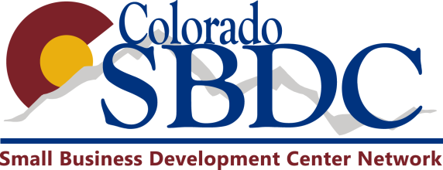
Date __________________________
Name of Consultant________________ ____________________________
Client _____________________________________________

SBDC Counseling Evaluation

Your response to this evaluation form is extremely important to us. Its purpose is to help us ensure our services are as meaningful and beneficial as possible. Feel free to add additional comments when appropriate.

Please rate the following using the scale below: 10 = Highest, 1 = Lowest.

10 9 8 7 6 5 4 3 2 1 n/a
1. How would you rate the skills, knowledge and quality of
business counseling you received?           

2. How likely are you to use the recommendations from           
this session?

3. How likely are you to return for additional counseling?           

4. How likely are you to refer other businesses to the SBDC?           

5. How helpful did you find the SBDC internet resources?           

6. How can we improve? ______________________________________________________________________________________________________
______________________________________________________________________________________________________________________________

7. How did you hear about the SBDC? ________________________________________________________________________________________
______________________________________________________________________________________________________________________________

Thank you for taking the time to fill out this survey. If you haven’t already done so, we encourage you to return to the SBDC to receive confidential, one-on-one consulting services.

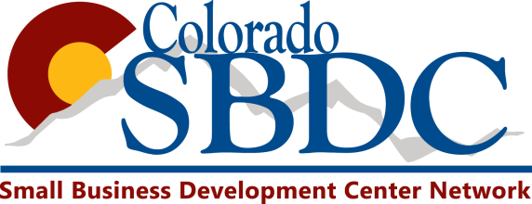
Date __________________________
Name of Instructor ____________________________

SBDC Training Evaluation

Your response to this evaluation form is extremely important to us. Its purpose is to help us ensure our services are as meaningful and beneficial as possible. Feel free to add additional comments when appropriate.

Please rate the following using the scale below: 10 = Highest, 1 = Lowest.

10 9 8 7 6 5 4 3 2 1 n/a
1. How would you rate the skills, knowledge and quality of
your instructor?           

2. How likely are you to use the knowledge you received from
this training event?           

3. How likely are you to return to another training event?           

4. How likely are you to return to the SBDC for counseling           
services?

5. How likely are you to refer other businesses to the SBDC?           

6. How likely would you be to enroll in an online training           
event?

7. How can we improve? _________________________________________________________________________
____________________________________________________________________________________________
____________________________________________________________________________________________

8. How did you hear about the SBDC? _______________________________________________________________
____________________________________________________________________________________________

Thank you for taking the time to fill out this survey. If you haven’t already done so, we encourage you to return to the SBDC to receive confidential, one-on-one counseling services.

