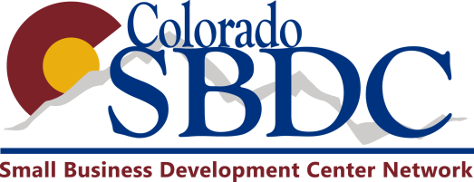

Online (email) Survey Questions – Impact Collection
These questions are to be used when making and emailing out online surveys (Center IC, Constant Contact, or adobe catalyst website workflows). These are not used for face-to-face interactions/sessions. For face-to-face sessions, the client will fill out the ‘Impact Collection Form’ found on the Director’s Resource Page.

- What is the current operating status of your business? Currently operating means you meet at least two of the following: formed a legal entity, received a loan, generated sales, hired employees or contractors, incurred expenses.
    - The business has not started operating yet
    - The business is currently operating
    - The business was operating, but now is closed down
    - The business was operating, but it was sold

- If the business is currently operating, what was the start date?
Estimated start date:

- Did the assistance you received from the Colorado SBDC help you with starting this business venture?
    - Yes
    - No

- Did the assistance you received from the Colorado SBDC help you with creating full time jobs? If no, please skip to the next question.
    - How many new full time jobs were created through the assisted you received from the Colorado SBDC?

- Did the assistance you received from the Colorado SBDC help you with creating part time jobs? If no, please skip to the next question.
    - How many new part time jobs were created through the assisted you received from the Colorado SBDC?

- Did the assistance you received from the Colorado SBDC help you with saving full time jobs that were at risk of being lost due to layoffs, closing business or declaring bankruptcy? If no, please skip to the next question.
    - How many full time jobs were saved through the assistance you received from the Colorado SBDC?
- Did the assistance you received from the Colorado SBDC help you with saving part time jobs that were at risk of being lost due to layoffs, closing business or declaring bankruptcy? If no, please skip to the next question.
    - How many part time jobs were saved through the assistance you received from the Colorado SBDC?

- Did the assistance you received from the Colorado SBDC help you in obtaining a loan? If yes, please enter the dollar amount. If no, please skip to the next question.
    - Commercial/bank
    - Private investor
    - SBIC
    - CDC
    - Line of credit
    - Other loan source
    - RLF

- Did the assistance you received from the Colorado SBDC help you with any owner investments you made? If yes, please enter the dollar amount. If no, please skip to the next question.
    - Equity cash
    - Credit card
    - Personal assets

- Did the assistance you received from the Colorado SBDC help you with any sales increase that you experienced last year? If yes, please enter the dollar amount. If no, please skip to the next question.
    - Sales growth
    - Business expansion
    - New business
    - New location
    - New product
    - Improved marketing
    - Business turnaround
    - Export sales
    - Franchisor sales

- Did the assistance you received from the Colorado SBDC help you obtain any contracts that have been awarded to your business? If yes, please enter the dollar amount. If no, please skip to the next question.

    - Commercial/Private Contract Count
    - Commercial/Private contract total dollar amount
    - DOD prime contract count
    - DOD prime contract total dollar amount
    - DOD sub contract count
    - DOD sub contract total dollar amount
    - Federal prime contract count
    - Federal prime contract dollar amount
    - Federal sub contract count
    - Federal sub contract total dollar amount
    - Prime bids submitted contract count
    - Prime bids summated contract total dollar amount

- I attribute that the assistance provided by the Colorado SBDC contributed to the results shown above
    - Yes
    - No

